Welcome!
Date
Name
Spouse
Address
City
State Zip _________
Email

Please Contact By
❑ Card  Phone  Visit

Telephone Best Time to Call
Home ______________
Work ______________

Guest: First Time Second Time
Are you a church member: yes no
Church
City, State

Circle Appropriate Age/Grade Group(s)
Preschool: Ages: B-1 2-3 4-5
Children: Grades: K 1 2 3 4 5 6
Youth: Grades: 7 8 9 10 11 12
Adults: Ages:18-29 30s 40s 50s 60s+

How did you learn about our church?
Newspaper Friend Yellow Pages Mail
Other

I am a guest of:

New in the Community? Yes No
Names & ages of children at home

Weekly Service & Activity Schedule

September 13, 2015

9:45 a.m. Sunday School
11:00 a.m. Worship Service
6:00 p.m. Evening Worship /Business Meeting

Week of September13, 2015

Wednesday 7:00 pm Adult Bible Study

Upcoming Events
September
13-19….…..….Week of Prayer – Mary Hill Davis Missions
20……………….. Operation Christmas Child Box Packing
23….See You at the Pole (Global Week of Student Prayer)
24…………………………………………..…Adult Fellowship
October
4…………………………Bridal Shower for Rachel Edwards
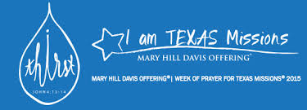

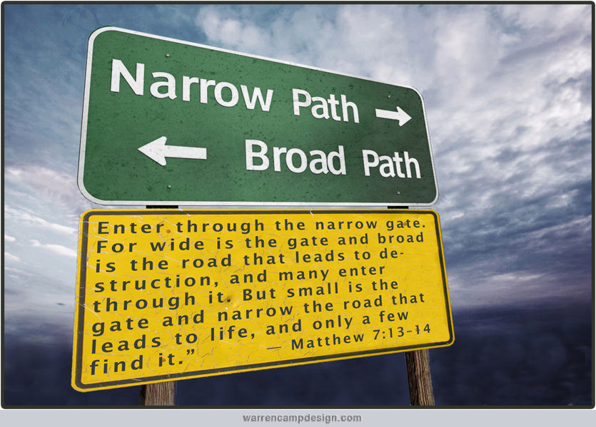

Knobbs Springs Baptist Church

September 13, 2015

Church Information:

KnobbsSpringsBC.com KnobbsSpringsBaptist@gmail.com

1662 CR 305, McDade, Texas 78650 512-273-2743

David Atwood, Pastor Cell 512-470-5098
Home 512-856-2819
Patti Radford, Office Manager Cell 512-968-7821

